31.14: a)
b) 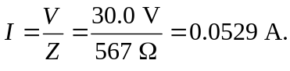
c)
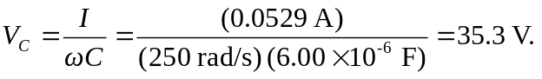
d) 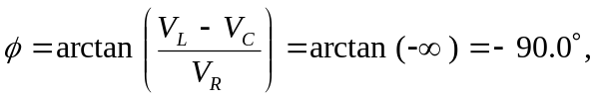 and the voltage lags the current.
e)

